**TABLE CREATION:**

CREATE TABLE ResourceTbl

(ResNo VARCHAR2(8) CONSTRAINT ResNoNotNull NOT NULL,

ResName VARCHAR2(30) CONSTRAINT ResNameNotNull NOT NULL,

Rate FLOAT CONSTRAINT RateNotNull NOT NULL,

CONSTRAINT CHECK_RATE CHECK (Rate>0),

CONSTRAINT PK_RESOURCETBL PRIMARY KEY (ResNo));

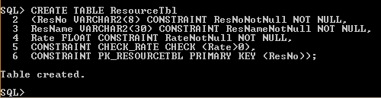

**SELECT STATEMENT:**

